**Typescript**

Interface, generics, decorators, namespaces, modules, compiler, JS libraries.

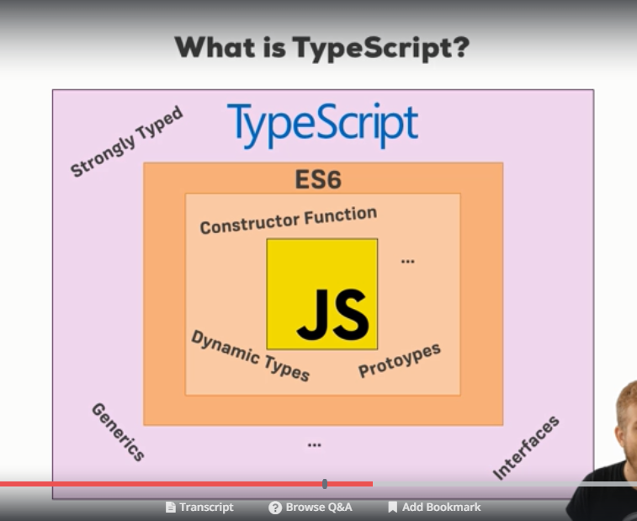

Typescript is a wrapper around JavaScript.

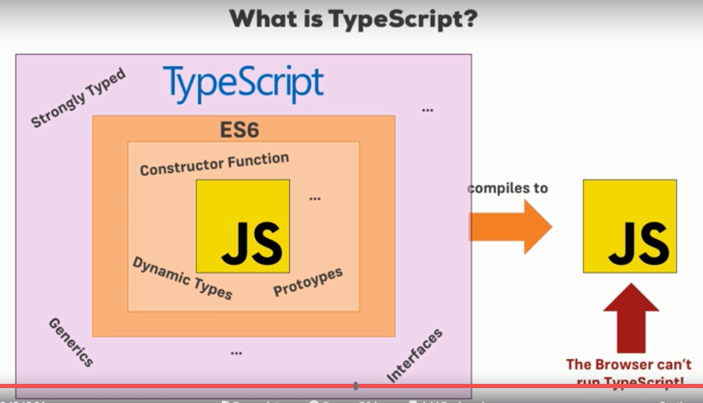



Command for compiling Typescript code into JavaScript



The compiler generates the JavaScript file. Typescript is JavaScript + some extra features.

Run npm init inside of the folder in which the project is there. Keep on hitting enter until defaults are fine, this will create the package.json file in the end.

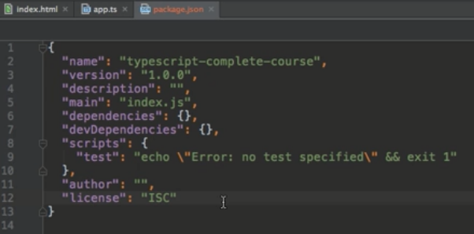

Install light server by using command - npm install lite-server –save-dev

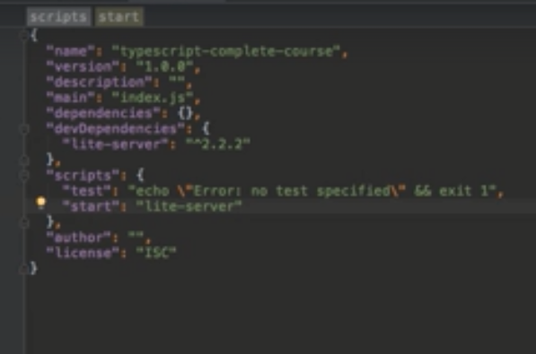

tsc –init will put this folder under the control of NPM, but now also to put it under the control of typescript we can say. This will create tsconfig.json file, which tells npm that this folder here is of typescript project. So, now by running tsc all the typescript files will be complied.

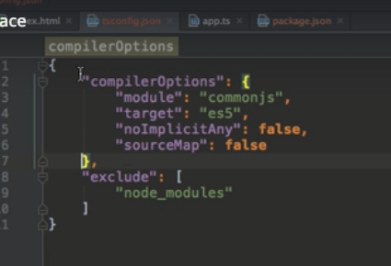

**Using types for better code**

Most important feature of typescript is types. We will learn which types exist and how we will create our own types.

In JavaScript we are not explicit about the variables we create, however, in typescript we are explicit about the variables.

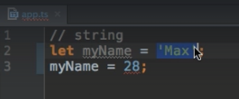



In JavaScript we have dynamic types, however, in typescript we have static types.

Typescript doesn’t differentiate between integer and float.

Assigning types explicitly:

If we don’t assign a type to a variable, then typescript considers its type as **any**.

*A lot of people define****static typing****and****dynamic typing****with respect to the point at which the variable****types****are checked. Using this analogy,****static****typed languages are those in which****type****checking is done at compile-time, whereas****dynamic****typed languages are those in which****type****checking is done at run-time.*

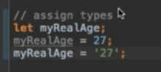

However, we can assign the type here:

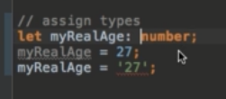

Now, it will give error

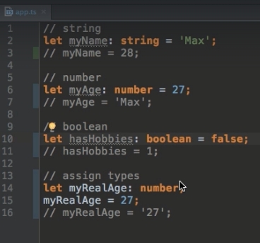

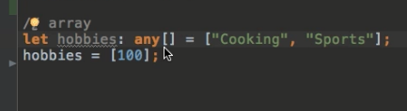

There is new type of mixed array, which can have mixed types i.e. **tuples**:

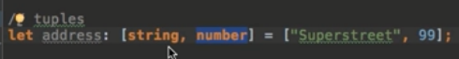

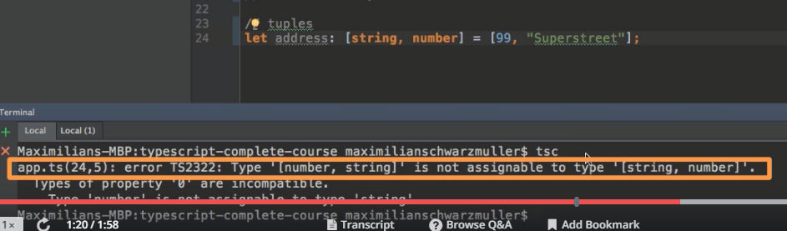

Order is important in tuples matters

Enum:

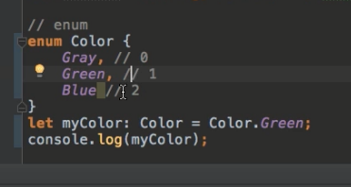

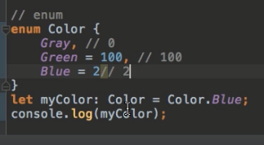

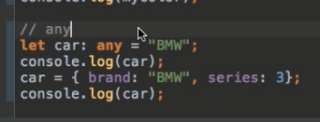

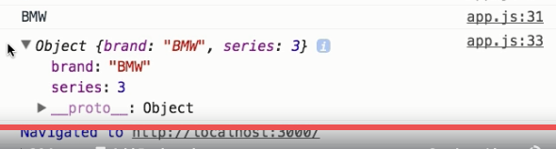

The role of typescript is to check the types at compile time, once it has passed that state, then it will give errors at run time – because it would be converted to JavaScript from and in JavaScript no types are there.

Using types in functions (Arguments and Return values)

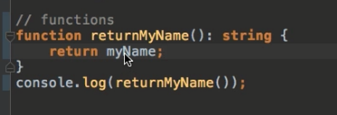

Function with return type void will give error if you try to return something, like below:

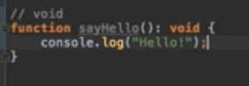

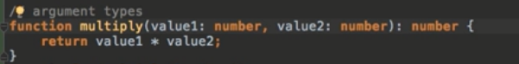

Functions are types in their own

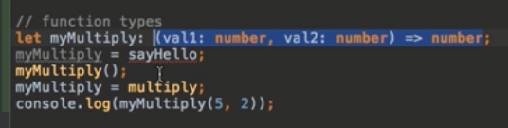

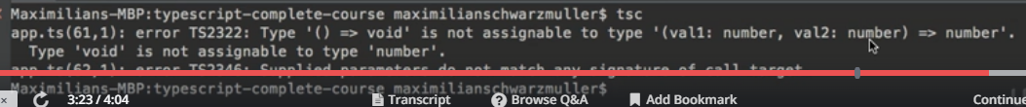

Objects in typescript:

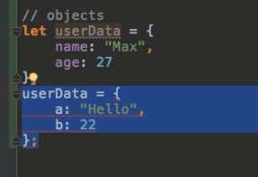

In objects the name of the initialized properties does matter.

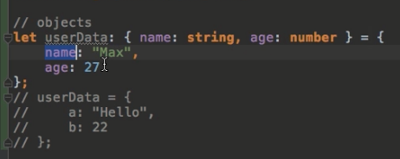

Complex typescript object

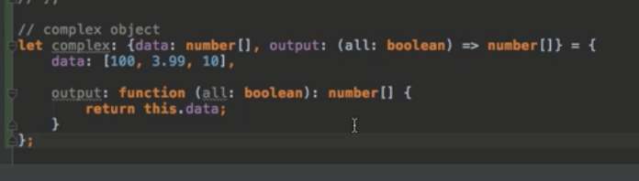

Custom types in typescript with Aliases

Alias type creation, which can be used when same complex type is to be used at multiple places:



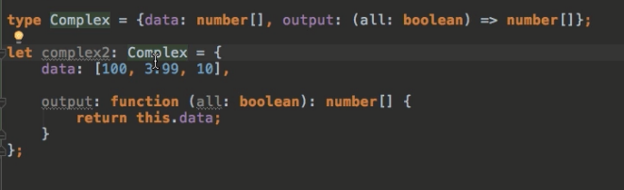

Union types – where we can assign more than 1 type to a variable

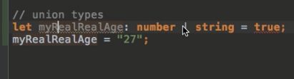

Checking for types during runtime

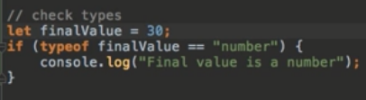

The “never” type

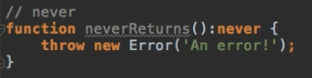

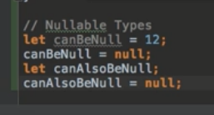

In tsconfig.json, we will now assign strict null checks to true:

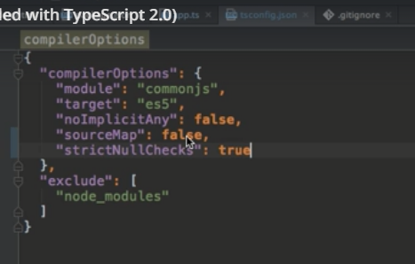

Now, we will get error upon compilation i.e. type null is not assignable to number.

**Understanding Typescript Compiler**

Typescript compiles the code even if the error has happened.

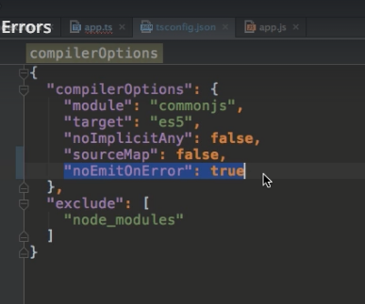

Default value of noEmitOnError is false; in this scenario the file will not get created when some error is encountered while compiling.

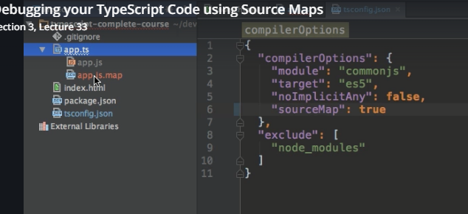

sourceMap file also got created once we made sourceMap to true. This option is used to debug the typescript file in the browser directly, as shown in the screenshot below.

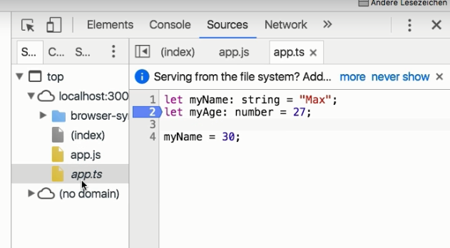

Avoiding implicit “any”

With the release of typescript 2.0 the compiler became a bit larger

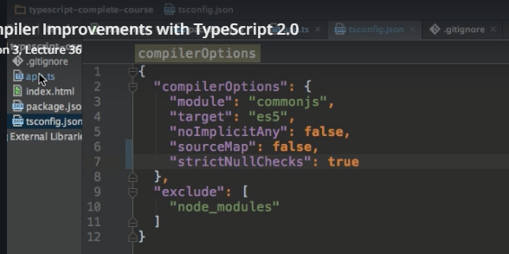

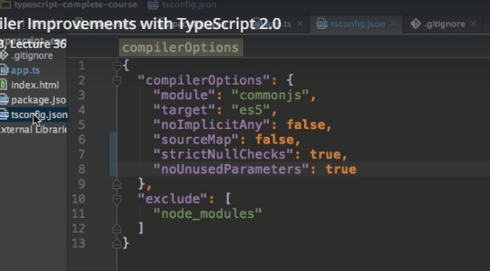

**Creating classes and Class properties in typescript**

Classes allow us to prepare blueprints for objects.

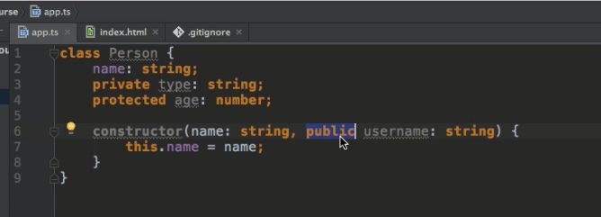

public username will be a new variable created in Person class

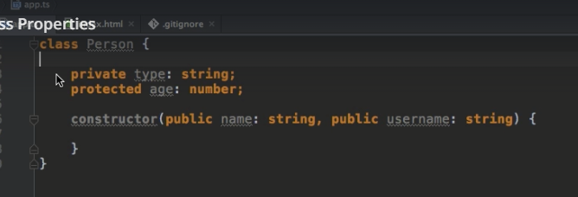

Instantiating constructor while creating new object

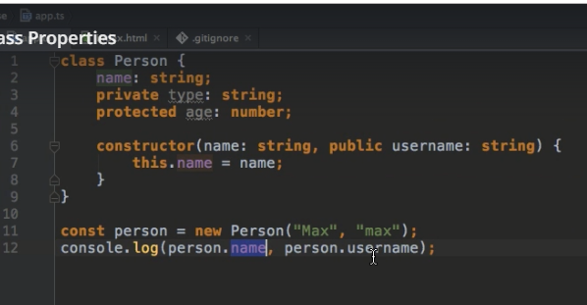

Class and Access Modifiers

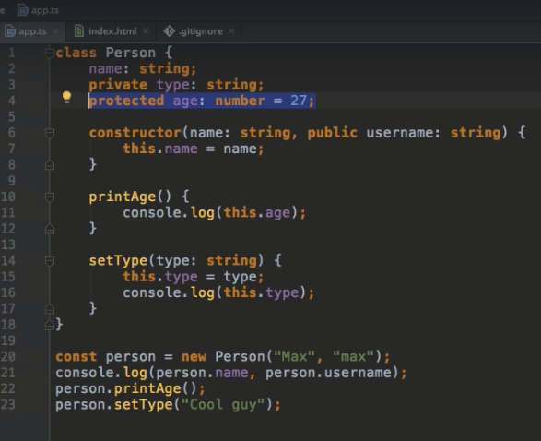

Accessing private method inside class

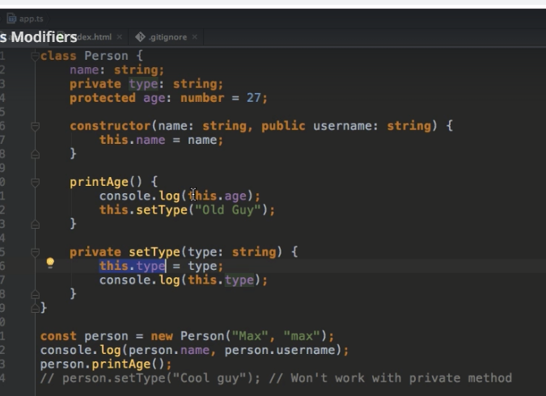

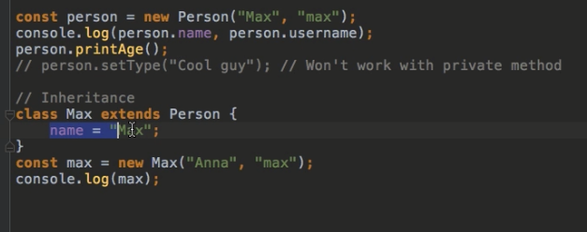

Here Anna which is the value passed to the constructor of parent, because child is not having any constructor; it will get overridden in the Max.

Inheritance and Constructors

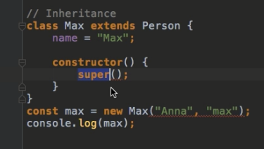

This will invoke the constructor of the parent class due to super(); keyword.

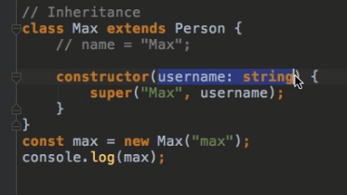

Inheritance wrap up

Getters and Setters

Introduction to name spaces

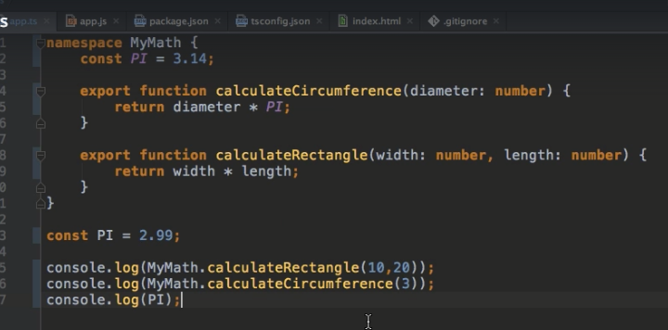

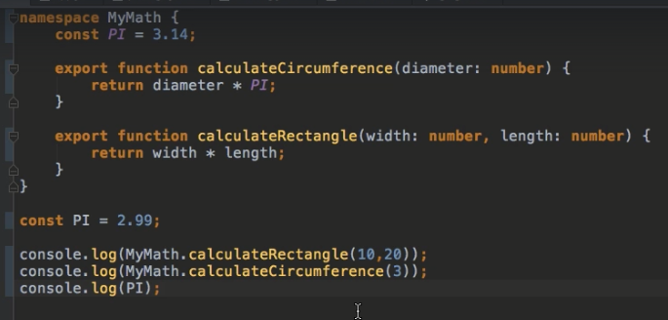

Namespaces and Multiple files

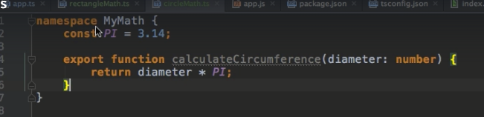

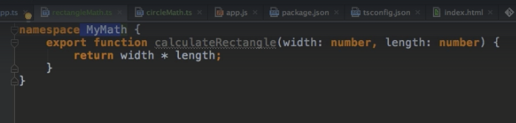

tsc –outFile app.js circleMath.ts rectangleMath.ts app.ts //command is used to create 1 single file out of all the namespace containing files

Namespace imports

Namespaces are imported using 3 forward splashes i.e. ///

It will add the namespace .ts files in the order on which we import them

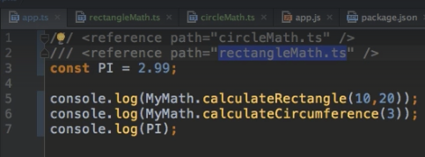

Nesting of namespace

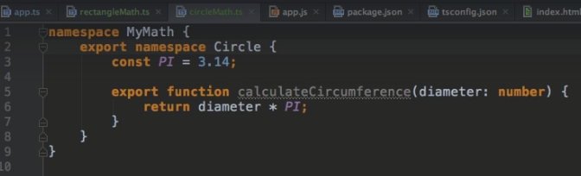

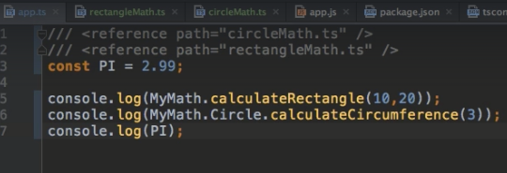

Second way to do same

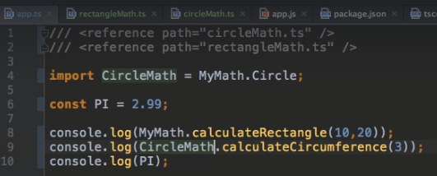

Limitations of namespace

Using namespaces its kind oh hard to check which file has which dependencies.

Modules are very declarative about which file has which dependency.

Namespaces are generally good for small size projects, whereas modules are good for medium and large size projects.

Modules

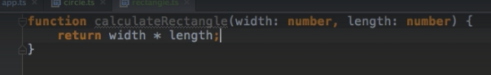

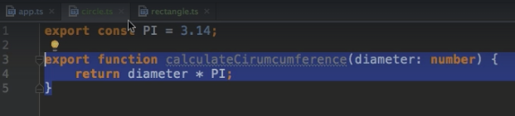

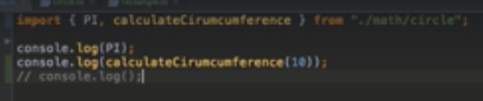

npm install --save [systemjs@0.21.5](mailto:systemjs@0.21.5)

All depends on how typescript transpires it depending upon the module loader system.

A popular module loader system is systemjs

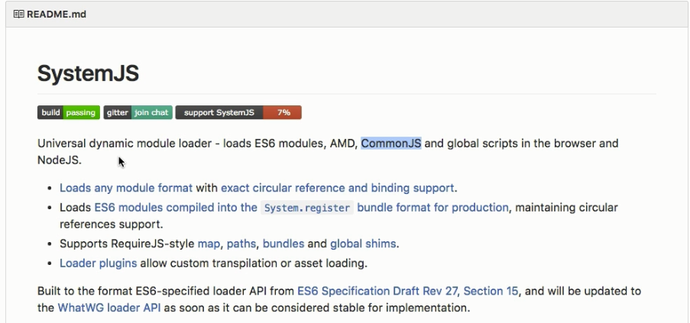

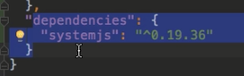

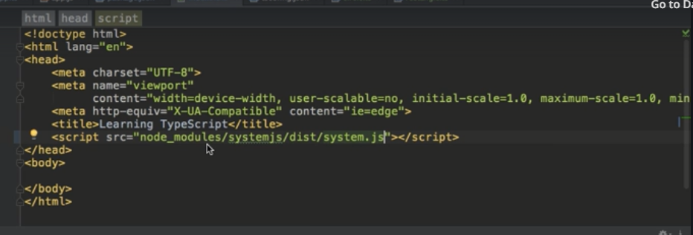

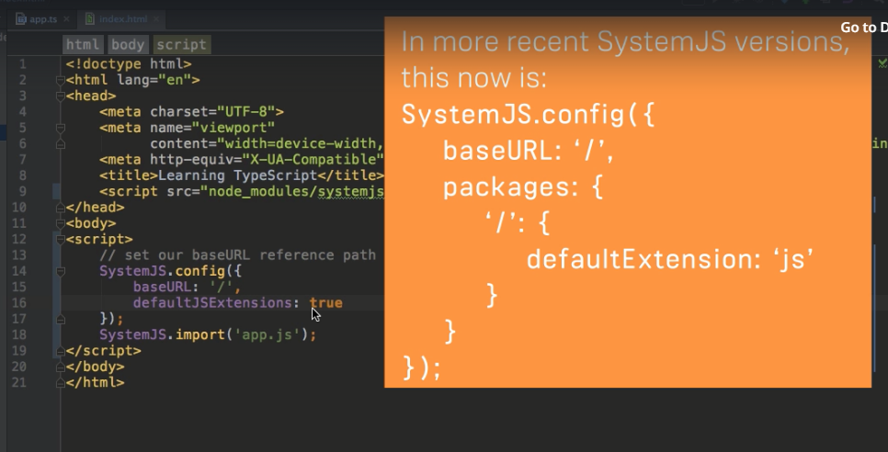

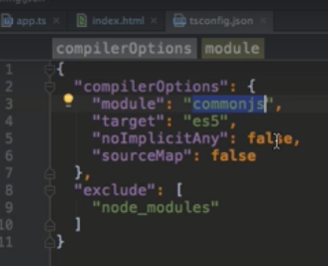

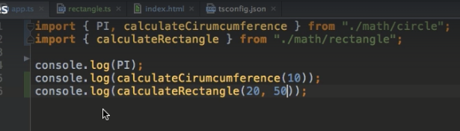

Another way

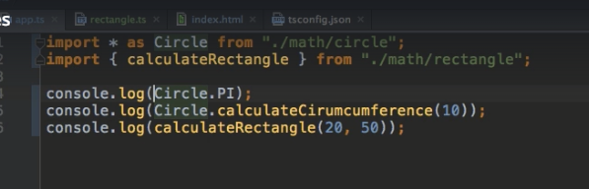

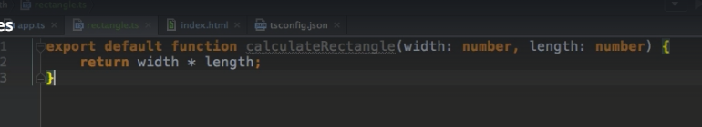

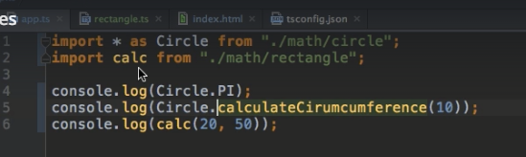

Module Resolution:

Typescript is very smart while resolving imports, it sees if it’s a relative path or an absolute path. The absolute path will always be locked up in the node_modules folder by default, or if you have an ambient typings definitions file, something to which I'll come back in a future module.

We will learn ambient typings in future.

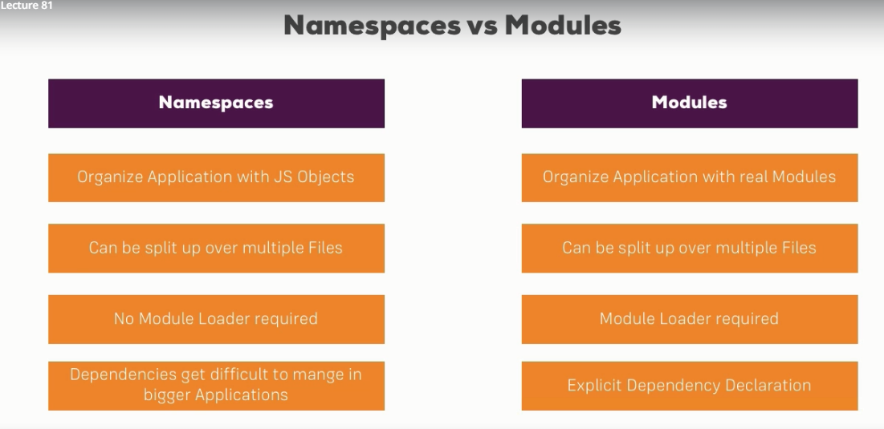

**Doing Contract Work with Interfaces**

Let’s look at some of the brand new features which are introduced by typescript.

What are interfaces and why would we use them?

1. An interface is a contract signed by the Object that I have this property, function etc.
2. 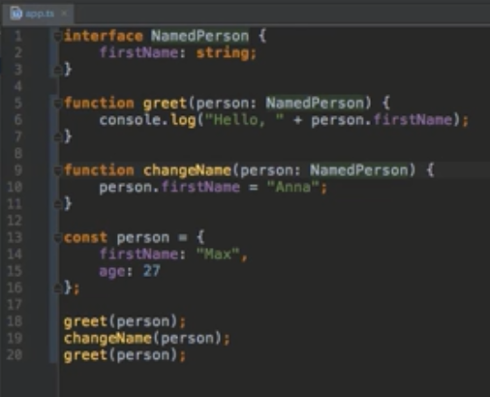
3. age is an optional property
4. 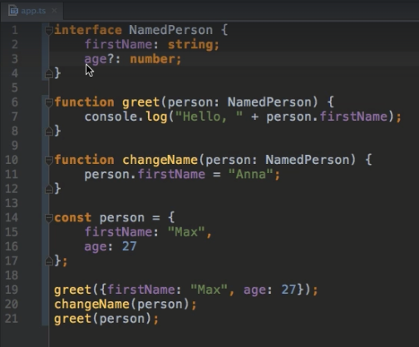
5. There might be some properties, where we don’t know the name of the property in advance/yet.
6. 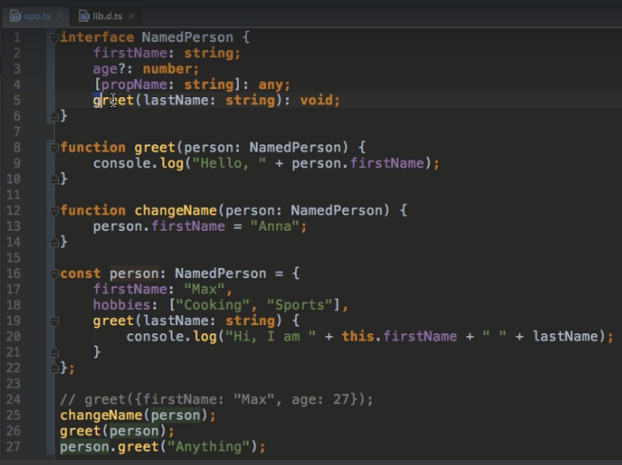
7. 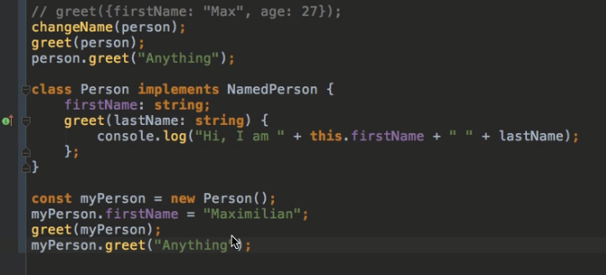
8. Interfaces and Function types
9. 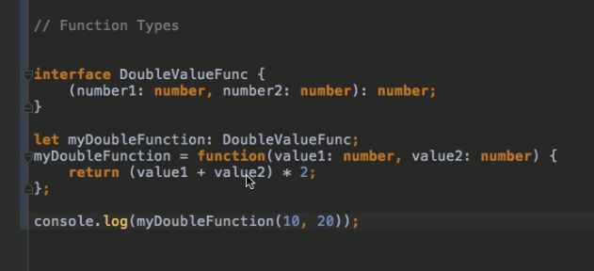
10. Here types of parameters should match
11. 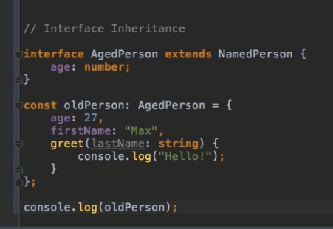
12. We have made age property a required 1 now
13. Interface does not get complied, they are just there to check our code during compilation and to give you compilation errors.

**Generics**

1. Dynamics is a powerful tool to write dynamic and flexible code.
2. 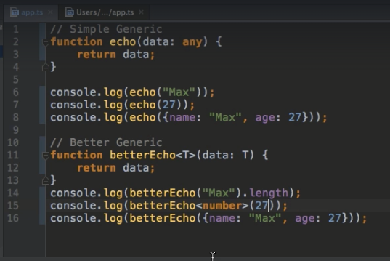
3. 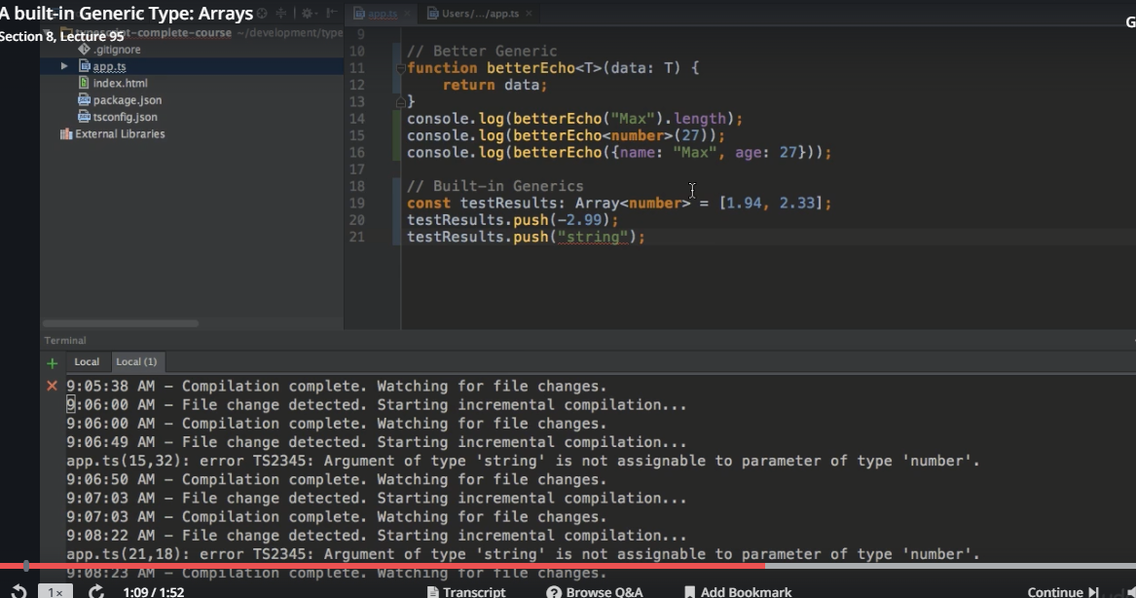
4. 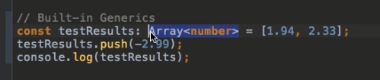
5. 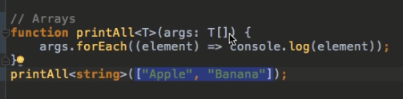
6. So far we had Generic functions, however, we can also have generic types.
7. 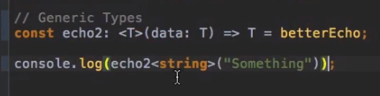
8. Creating a Generic Class
9. We have generic functions and generic types; however, we also have generic classes.
10. 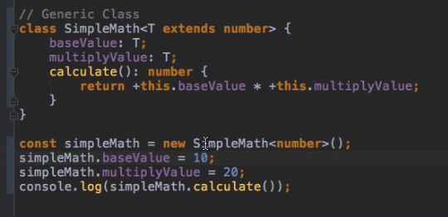
11. 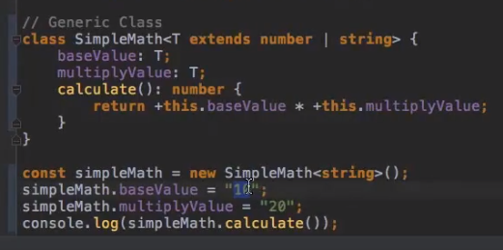
12. Using more than 1 generic type
13. 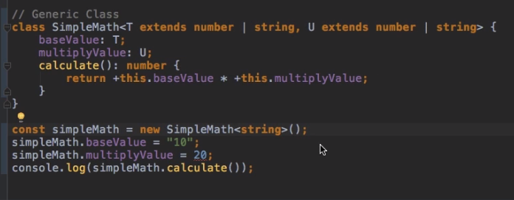

**Behind the Scenes with Decorators**

1. Decorators are the functions that we can attach to methods, properties, classes etc. So, decorator will work with them and transform them.
2. Creating a class decorator:
3. Decorators are the features of typescript, so typescript manages which arguments should be passed to the decorator by default.
4. If we attach the decorator in a class it will get only 1 argument as the Parameter that would be the constructor of that class.
5. 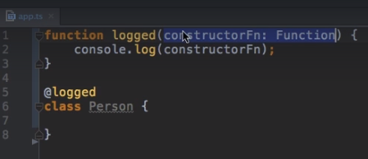
6. 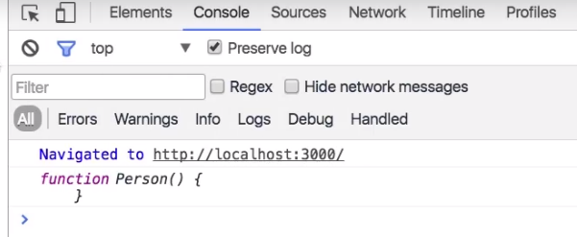
7. 
8. 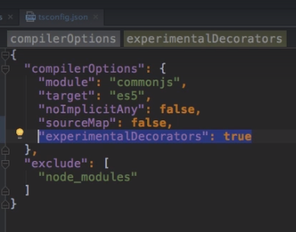
9. 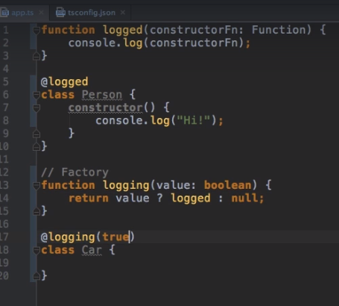
10. 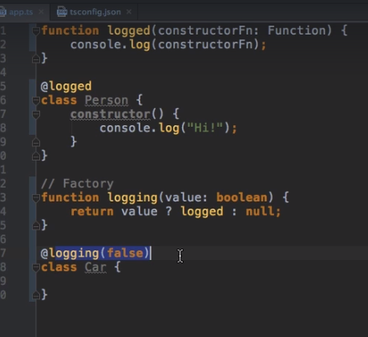
11. Creating a useful Decorator
12. 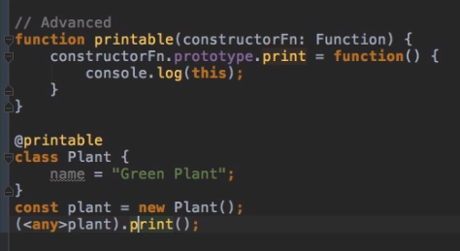
13. Using multiple decorators
14. 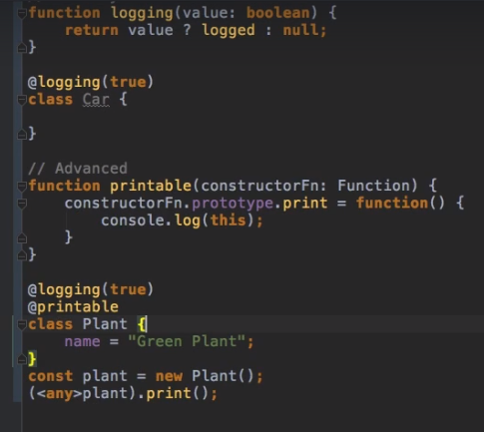
15. Method Decorator
16. 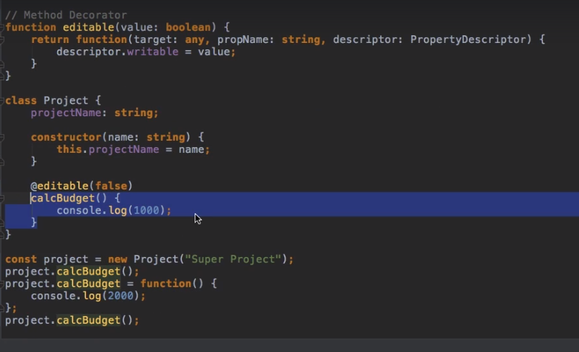
17. Here we have made calcBudget method non-re-writable using method decorator
18. Property Decorator
19. 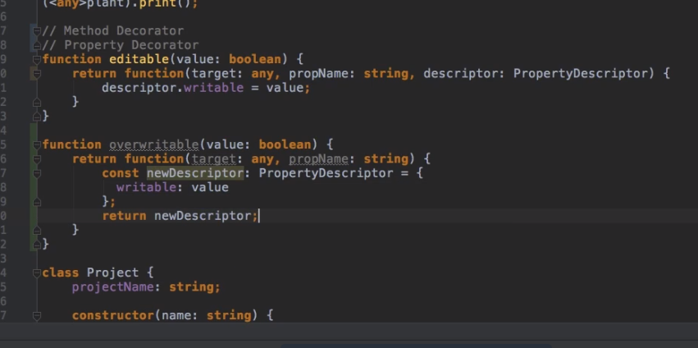
20. 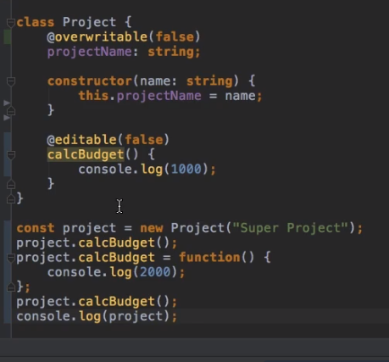
21. Parameter Decorator
22. 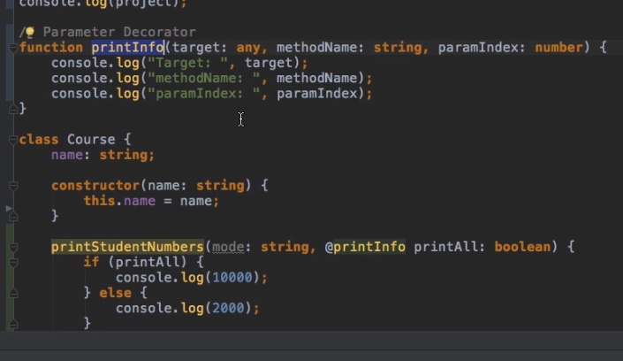
23. 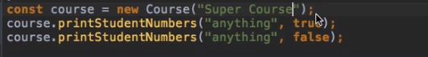
24. Using tsc and tsconfig file
25. When we run tsc command, it looks for tsconfig.json file to check what the configuration is, on which it should run.
26. tsconfig file tells it to run any file in the folder except node modules folder.
27. 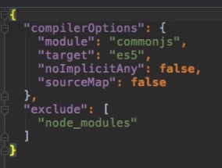
28. Here we have excluded the node_modules folder.
29. Typescript into a gulp flow:
30. 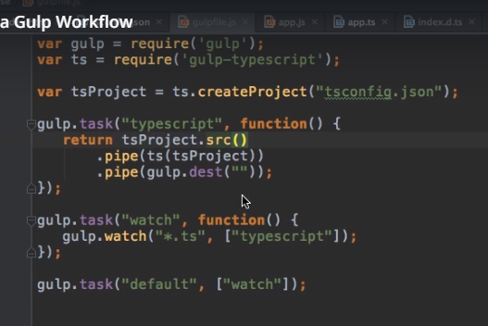
31. 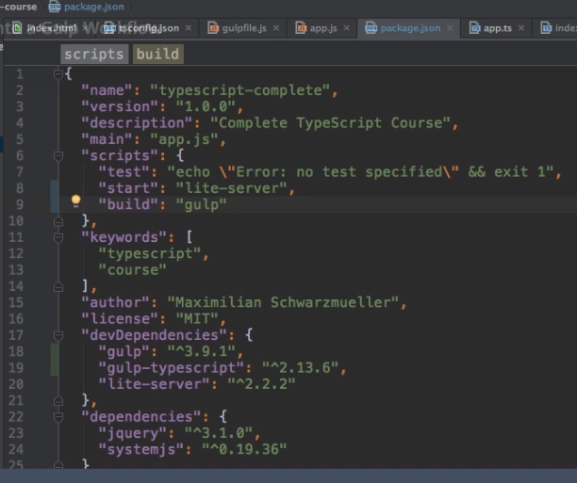
32. Adding typescript into webpack flow
33. 
34. When we are using the webpack to compile the code then we don’t need system JS code in the index.html
35. 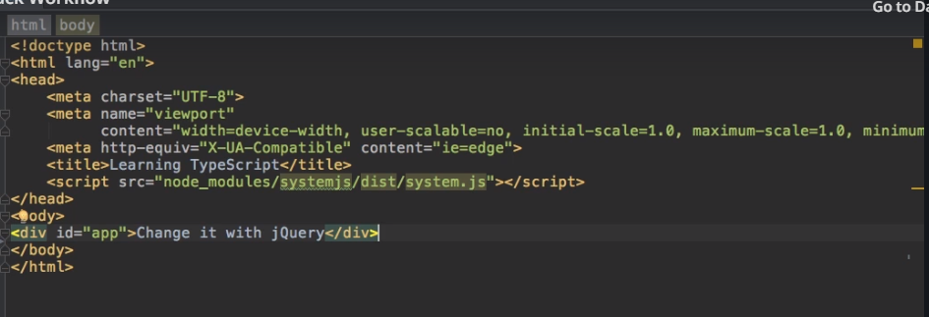
36. 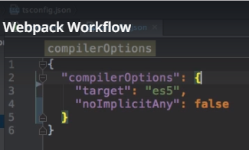
37. Here we will add another file i.e. webpack.config.js
38. 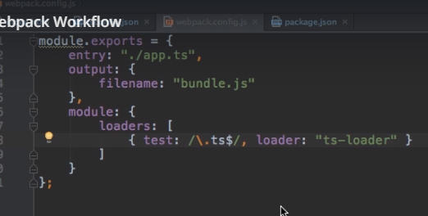
39. 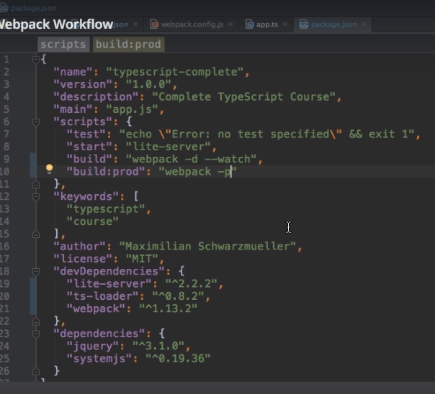
40. 